Görkem Enes Bektaş
bektasgorkemenes@gmail.coım
Politechnika Czestochowa

Berke Can Kaya
bluten07@gmail.com
Politechnika Czestochowa

Signal analysis and Data processing

Laboratory Class - Experiment 2

Probability density function (PDF)
Introduction
This report documents the analysis of Probability Density Function (PDF) distributions for various signal types, including random, deterministic, and compound signals. The primary focus is to investigate the effects of stationarity, sampling rates, bin numbers, and noise levels on the accuracy and clarity of PDF distributions. Each step provides insights into optimizing signal processing tasks while maintaining a smooth and interpretable PDF. The tasks are performed in accordance with the given experimental guidelines.

Compulsory Tasks
- perform statinarity test for either random or compound signal
The stationarity test ensures the signal length is sufficient for accurate PDF distribution
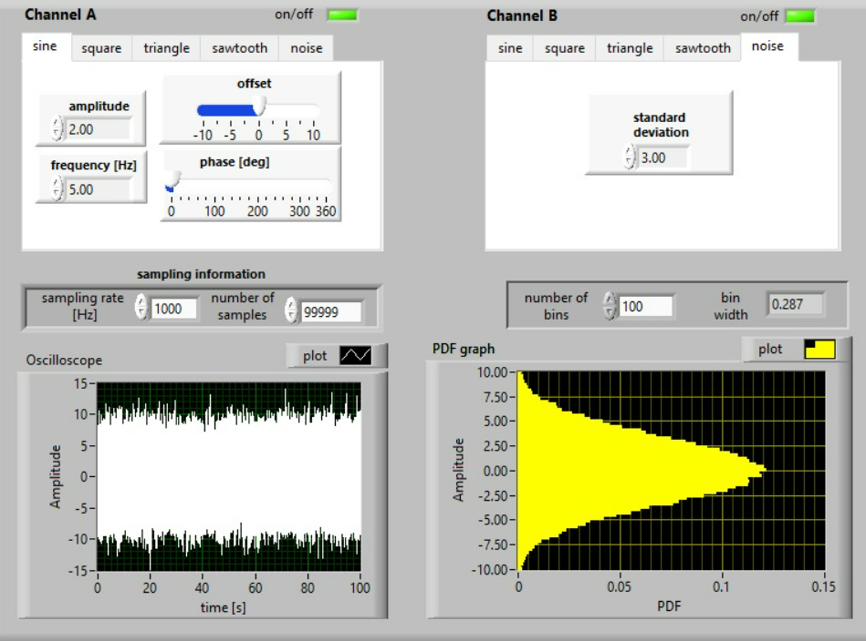
Figure 1 Number of samples=99999=max
A high number of samples results in a smooth graph, confirming stationarity and sufficient length for reliable PDF representation.
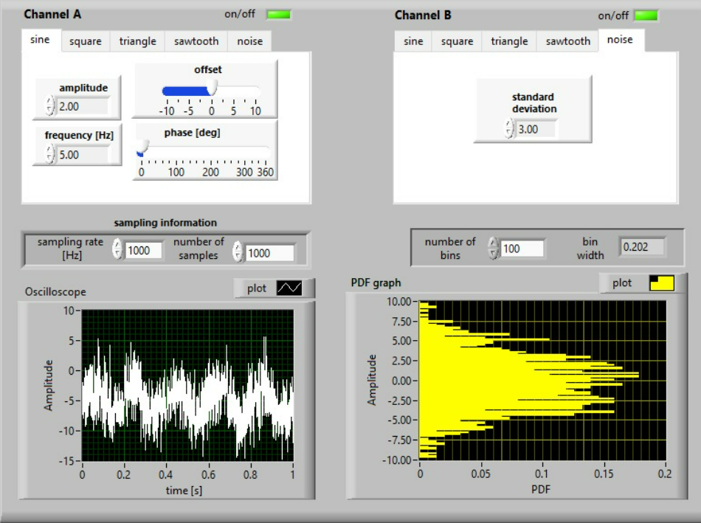
Figure 2 Number of samples=1000
With fewer samples, the graph is unclear and noisier, indicating that the signal is less reliable for analyzing the PDF.
- estimate the required number of intervals (bins) ensuring smooth PDF distribution for the selected signal
This task involves identifying the ideal number of bins for smooth PDF distribution
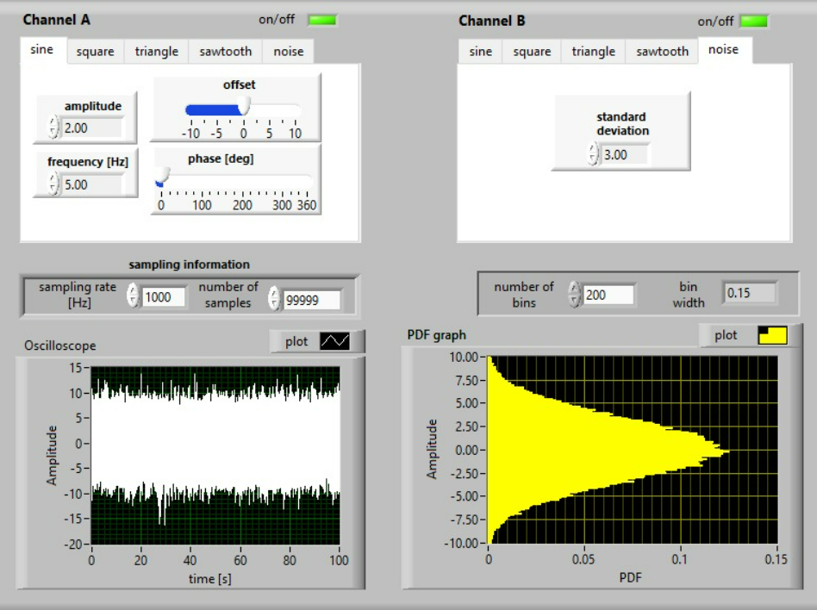
Figure 3 Number of bins=200
The graph is smooth, showing a properly chosen number of bins that minimizes noise without over-smoothing the data
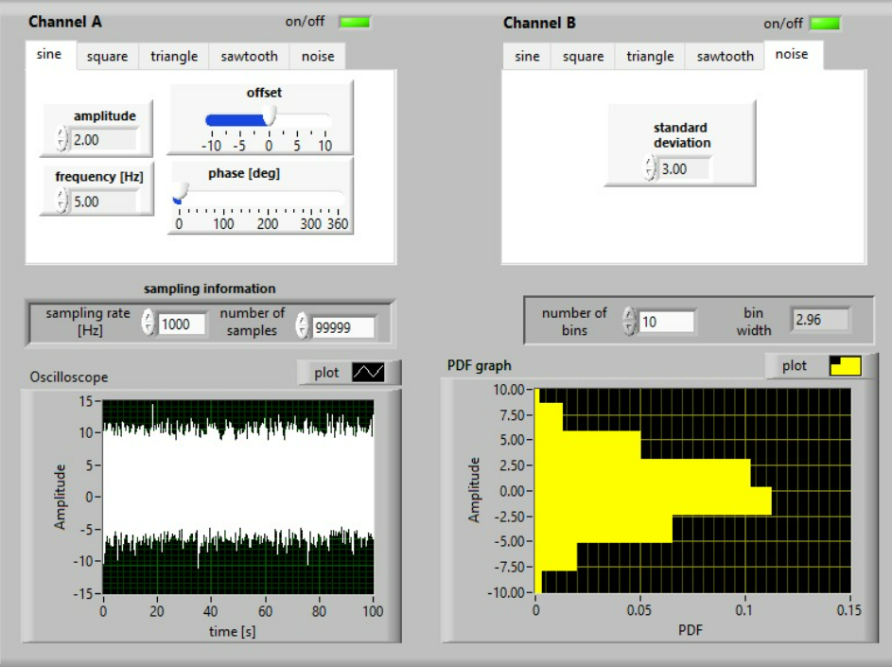
Figure 4 Number of bins=10
A lower bin count results in an unclear graph with blocky and inaccurate representation of the PDF.
- determine the PDF distributions for typical deterministic signals
The goal here is to compare PDF distributions under different sampling rates and waveforms
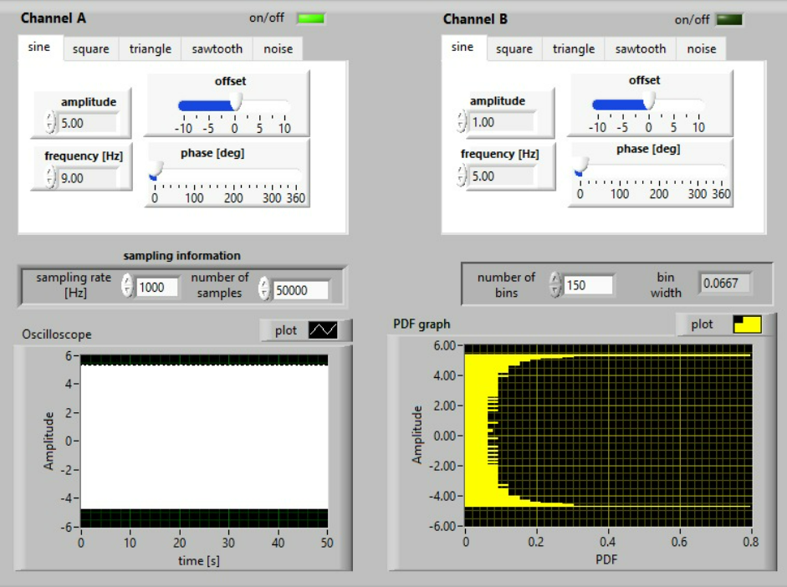
Figure 5 Sampling Rate=1000Hz, unclear graph
The graph appears unclear, suggesting that the sampling rate is insufficient to capture the signal details accurately.
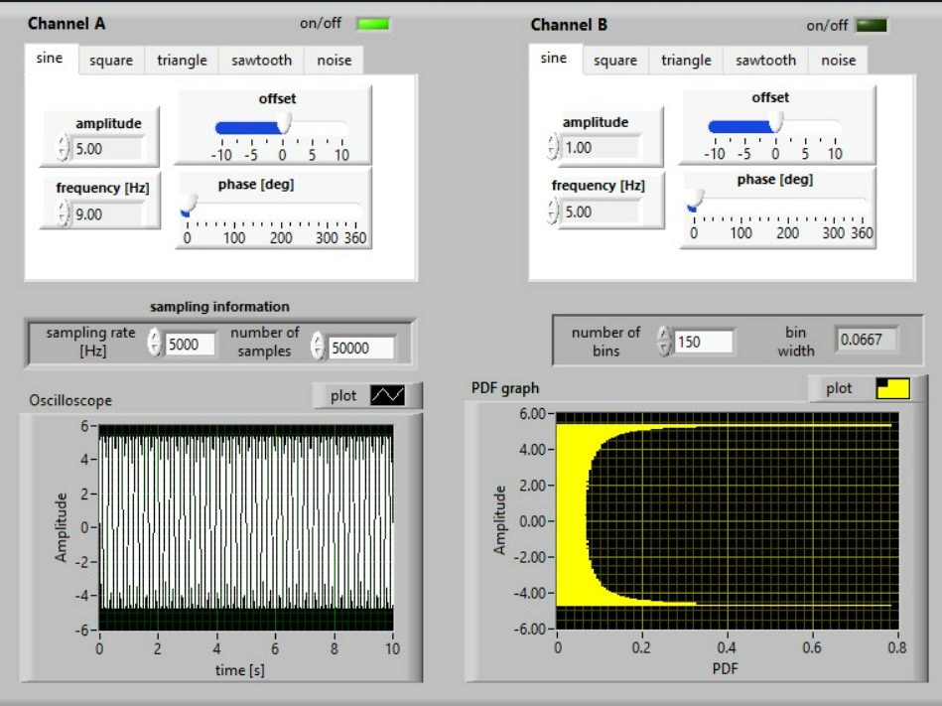
Figure 6 Sampling Rate=5000Hz, smooth graph
A higher sampling rate results in a much smoother graph.
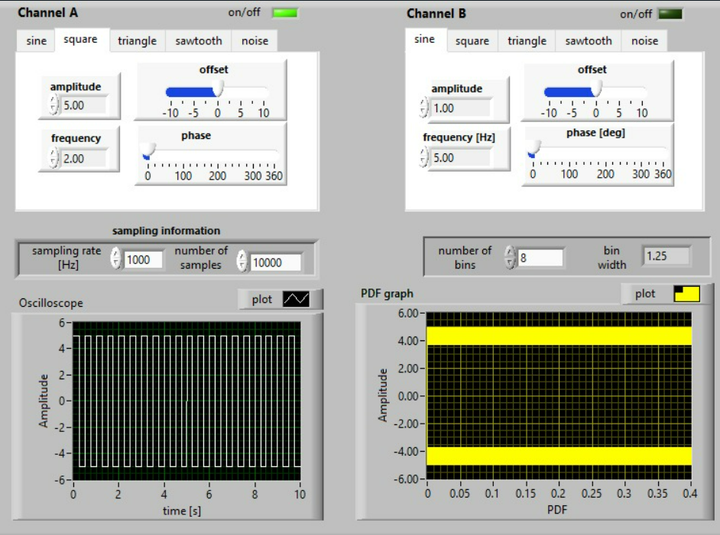
Figure 7 Square Wave
Displays sharp transitions, indicating clear periodic behavior.
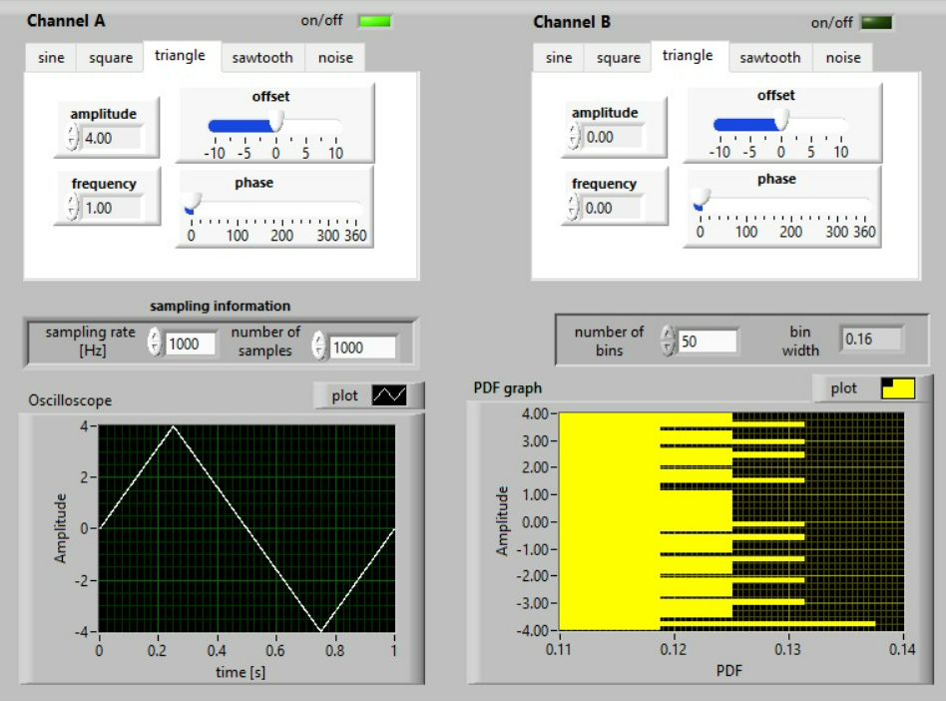
Figure 8 Triangle Wave
Smooth, gradual transitions consistent with the waveform's characteristics.
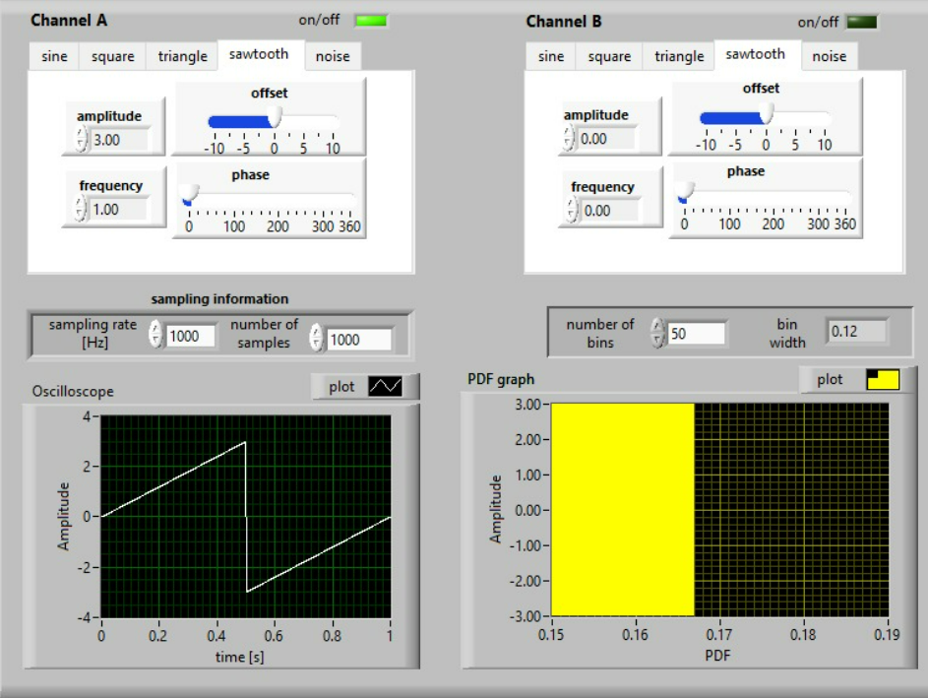
Figure 9 Sawtooth Wave
Displays a linear rise and sudden drop-off, matching the signal's definition.

d) determine the PDF distributions for selected compound signal changing the level of noise contribution
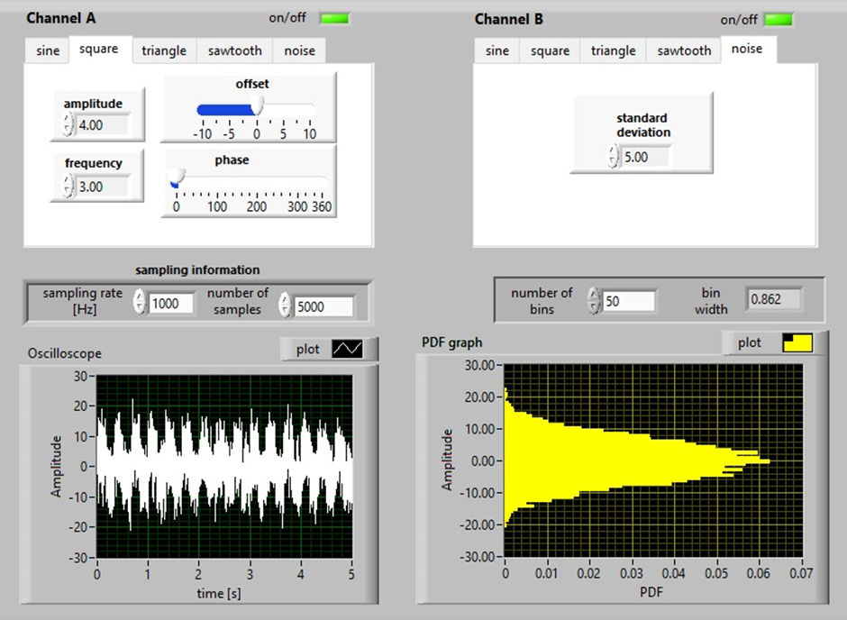
Figure 10 square + noise; amplitude =4, standard deviation = 5
The PDF for a square wave with added noise (amplitude = 4, standard deviation = 5) shows that the noise significantly affects the visibility of the signal. The total power NNN is calculated as:
N = σ²_{sig} = σ²_{squ +} σ²_{noise} σ²_{squ} = Amplitude
N = 4² + 5² = 16+25 =41
%Total Power = $\frac{Power of noise}{Power of signal}×100= \frac{25}{41}×100=\%60,97$
If the amplitude goes up or the standard deviation goes down, the graph becomes more visible, easier to recognize.
Conclusion
The experiments demonstrate the critical factors influencing PDF clarity and smoothness in signal analysis. Adequate signal length ensures stationarity, while optimal bin counts and higher sampling rates yield smoother PDFs for deterministic signals. Noise significantly impacts compound signal PDFs, requiring careful consideration of noise amplitude and standard deviation for better signal characterization. These findings underscore the importance of parameter optimization in achieving reliable and interpretable PDFs in signal processing tasks.

